Workshop for the 33rd Annual Conference of the Association for Teacher Education in Europe,

Vrije Universiteit Brussel, Campus Etterbeek, 23rd - 27th August 2008

Designing educational means based on the conceptions of pupils’ in The Netherlands and Ukraine

Jolien van der Geugten¹, Olena Shyyan², Fred Brinkman¹ & Thomas Jager³

¹INHolland University of Applied Sciences
Research Centre of Media, Culture & Citizenship
Diemen, The Netherlands
E-mail: Jolien.vandergeugten@INHolland.nl
E-mail: Fred.Brinkman@INHolland.nl

²Lviv In-service Teacher Training Institute
Department of Life Competence
Lviv, Ukraine
E-mail: olshyyan@hotmail.com

³INHolland University of Applied Sciences
Language Academy/School of Education
Amsterdam, The Netherlands
E-mail: Thomas.Jager@INHolland.nl

Project website: www.surfgroepen.nl/sites/EastWest

- Introduction

The workshop was the follow up of the keynote speech of Fred Brinkman at the 33rd ATEE conference. He elaborated there an international research project about health and environmental education in The Netherlands, Belarus and Ukraine. In this article we report about pupils’ concepts, and the subsequent development of educational means which aim to influence the attitude of pupils. Some of the differences and similarities between pupils in The Netherlands and Ukraine will be presented as well.
For the past ten years students of the INHolland university together with teachers, did research on pupils’ and teachers’ perceptions about several aspects of life, health and environment in The Netherlands, Ukraine and Belarus. Based on the research outcomes several educational means have been developed, aiming to make pupils and teachers realize their own conceptions and prejudices, and to change their attitude on issues about health and environment. For example a pantomime game and a documentary are developed (De Vries, 2005; Brinkman, Goddijn & Tarasov, 2005).
In the project year 07/08 the Dutch research team consisted of two students of Pedagogic, one student of Communication and three teachers of the INHolland University. The research questions in this project were:
- Which conceptions can be found in the relations between boys and girls in The Netherlands and Ukraine?
- Which of these conceptions can be used in a teaching strategy for effective sexual health education?
The purpose of the project was to develop a communication strategy in health education based on the own conceptions of pupils, in particular what boys think about girls and what girls think about boys.
It is well known that boys and girls differ in their development (Van Beemen, 2001). For example, boys are busy to decide who’s the leader in a group, which leads to more competition between boys. In general boys are more aggressive, active and impulsive than girls. While girls are more prepared to cooperate and negotiate. For girls it is important to share their feelings (Van Beemen, 2001). Also the development of boys is slower than the development of girls, who are sooner in their puberty (Van der Doef, 2003). Besides that, young people are more often and earlier sexual active (Garssen, 2002). And young people are in their adolescents more flexible when it comes to stereo-type gender roles. Adolescents are more aware of the other gender because of their physical changes, but still they want to be a part of the same age and the same gender group. In the beginning of their puberty young people will depend on sex-stereotype behavior. This is because they feel more attractive to the other gender (Van Beemen, 2001). All these differences between boys and girls can lead to misunderstandings between boys and girls in trying to understand the other gender and getting involved in relationships with each other.
Boys and girls who are having relationships with each other got to deal with (health) risks in life, it doesn’t matter if they live in Eastern or Western Europe. Teenagers should not only have the knowledge, but they should also have a responsible attitude towards those risks. Lack of education about relational and sexual development possibly leads to negative sexual experiences and confusion about physical changes in puberty (Pronk, 2007). In whole Europe pupils and teachers have to deal with (sexual) health issues like the spread of sexual transmitted diseases as HIV/Aids, which especially hits Eastern Europe (AFEW, 2007; UNAIDS, 2008). Sexual health is defined on the World Health Organization website (n.y.) as follows: ‘Sexual health is a state of physical, emotional, mental and social well-being in relation to sexuality; it is not merely the absence of disease, dysfunction or infirmity. Sexual health requires a positive and respectful approach to sexuality and sexual relationships, as well as the possibility of having pleasurable and safe sexual experiences, free of coercion, discrimination and violence. For sexual health to be attained and maintained, the sexual rights of all persons must be respected, protected and fulfilled.’
Investigating the conceptions of boys and girls in The Netherlands and Ukraine gives the opportunity to compare them between those countries, and to learn from each other’s culture and way of thinking. Pupils and teachers in Europe got to deal with sexual health issues, but they all have their own different cultural background. They have ideas in common but differ also in norms, values, religion and taboos. Those aspects have to be taken into account by the development of educational means about sexual health. (Van der Geugten, et al., 2006). Developing educational means based on the target groups’ own conceptions influence the knowledge, attitude and behavior of that target group (Kievits, Huisman & Brinkman, 1998).
In the project East West we cooperate with schools, universities and health organizations in The Netherlands and Ukraine. Students Sociology of the National Taras Shevchenko University Kiev, health organizations Aids Foundations East West (AFEW), Transatlantic Partners Against Aids (TPAA) and SALUS foundation, and several local teachers supported us in evaluating our research method and educational means. Olena Shyyan is the cooperating partner of the Lviv Inservice Teacher training Institute in Ukraine. That organizes long term teacher trainings for health educators’ professional development. The project East West provides educational means to use and evaluate with these health educators.
In paragraph 2 contextual aspects of The Netherlands and Ukraine are described. Paragraph 3 describes the research methods. The results are described in paragraph 4. Finally the conclusion and opportunities for further research are given.

- Contextual aspects of The Netherlands and Ukraine

The Netherlands
In The Netherlands sex is everywhere: on the television, the street, etc. But before the sixties the Dutch society was very prudish. Nobody spoke about sex, parents didn’t give any sexual education and at school friends also didn’t mention it. Everything had to be find out and discovered by themselves.
Youth who grew up in the sixties have changed the prudish attitude. Sexuality became separate of reproduction by the introduction of the birth control pil. Since then it was possible to have without the fear of getting pregnant (Brink & Los, 2007). At the end of the sixties the first sex magazine was made. Porn was forbidden, so it was sold illegal till an amendment of law. From that time on offensive pieces of writing and pictures for decency could be shown openly.
Since the sixties people are having sex on a younger age, because of using the birth control pil. There is no longer taboo on sexuality. Youth is advised to have safe sex. And homosexuality can be discussed (Rigthart, 1998).
In the eighties HIV/aids was first known as the homosexual disease, with the name GRID (Gay Related Immune Disease). Because till then only homosexual men were infected. In 1984 it was known that the disease was the consequence of the HIV-virus, which could infect everyone. That’s why the Dutch government decided to start a campaign with the advice: Have save sex. Stop AIDS.
In these days pupils are becoming more voluptuous and are dancing indecent at school parties (‘AD’, 2007). The General Pedagogical Centre wants measures to stop this behavior. It seems that schools don’t work on this. It is statutory for secondary schools to give sexual education to pupils. The school can decide in which subject the sexual education takes place, most of the time biology. There are different educational means available about sexuality (Van Helden & Simons, 2007).

Ukraine
The concept of continual health education in Ukraine and the new subject “The Valeology” (the science about health) was included into the basic curriculum of the comprehensive secondary school in 1994. Promoting motivation for health maintenance and commitment to healthy life style among youth was defined as one of the main tasks of school. The problem of special teachers’ training for promoting the rules of safe behavior among youth preventing negative influences on their health, has gained special importance. There appeared a need of special staff training in higher education establishments and post-graduate education institutions.
Due to the fact that in higher education establishments training lasts longer and the teachers were needed immediately, at that stage in Lviv Regional Institute of Post-Graduate Pedagogical Education there were implemented short-term courses “The Valeology Basics” and “The Culture of Health”. First time modules “Sex in Human Life” and “AIDS” were included to teacher training courses. The author’s experience as a trainer of the above-mentioned courses is the evidence of big interest of the teachers of different disciplines to them (Shyyan & Shyyan, 1997). Besides, at that time there started a discussion among scientists and methodologists concerning the major of a teacher, to whom valeology teaching could be delegated, which has been going on up to now.
Analysis of implementation the “Valeology” is the evidence of growth of the students’ interest to the subject during the first five years. Unfortunately, gradual decrease of opportunity to provide this program at schools in Ukraine was observed after 2000. First of all this happened because of unexpectedly changes in status of the subject (from obligate to optional) at that time (Shyyan, 2005).
It is important to indicate that since 2005 the new obligate subject “Health Basic” was provide in school curriculum in Ukraine. It formed the new tasks. One of the main tasks is the same as it was in 1994 to train the teachers of health education. In these conditions it is necessary to train an educator not only as a teacher of a separate discipline at school but also as the subject of promoting healthy life style of all participants of educational and pedagogical process.
Apparently, the experience of teachers’ training organization for implementation of courses motivating youth for healthy life style and integrating them into the system of education, which was accumulated by European countries, is valuable for generalization and creative use in the Ukrainian system of education in general and at the regional level in particular. An international research project about health education deals to the development of a teaching strategy for secondary school pupils are very useful for conducting comparative analysis of implementation of health basics education programs in the schools and teacher training institutes (Van der Geugten, Brinkman & Jager, 2006).
Despite the fact that the views on health basics education do not always coincide, the society always contains a substantial array of general human values, which has set for it general tasks that insignificantly depend on the cultural, social and organizational context. Admitting this induces not ignoring cultural and contextual differences but rather creating the integrating framework for solving most important problems of education in the epoch of strengthening globalization. Investigation of using research methods and educational means to investigate pupils’ and teachers’ cultural help to observe differences in approaches to Health education and gender secularities.

- Research methods

Population
In The Netherlands pupils from secondary schools are investigated. In Ukraine pupils from secondary schools, teachers who attended the Lviv Inservice Teacher Training Institute and students of the Lviv Institute of postgraduate pedagogical education were involved.

Research instruments
This investigation consisted out of five parts (figure 1), based on Schellens (2000), Brinkman (2004) and Ausubel (1968). First the context and the literature is analyzed about the research question. Secondly the conceptions of pupils in The Netherlands and Ukraine were inventoried by using the HC Test (Boschhuizen & Brinkman, 1995). Thirdly the communication message and the goal of that message were defined for each country, based on the results of the HC Test. The development of educational means based on their own ideas is in accordance with the statement of Ausubel (1968) that ‘the most important single factor influencing learning is what the learner already knows’ (p. 287). With the communication message and the communication goal educational means were developed. Fourthly the educational means were tested to measure the effect on the target group. Finally the educational means were evaluated.

Figure 1: Designing educational means based on the concepts of people
- Analysis of context and literature

- Conceptions of the research group (HC Test)

- Designing educational means

- Effect on the research group. (HC Test)

- Evaluation of the educational means

To explore the conceptions of the pupils with the HC Test the following steps had to be carried out:

Step 1: Collecting associations (10 minutes)
The pupils are asked to write down words were they think of when they think of the stimulus word. The stimulus word is the concept that is tested, in this case for boys ‘girls’ and for girls ‘boys’ (figure 2).

Step 2: Clustering of associations into groups (10 minutes)
The pupils are asked to arrange their associations into coherent groups of their opinion (figure 2). It’s up to them how many associations belong to one group.

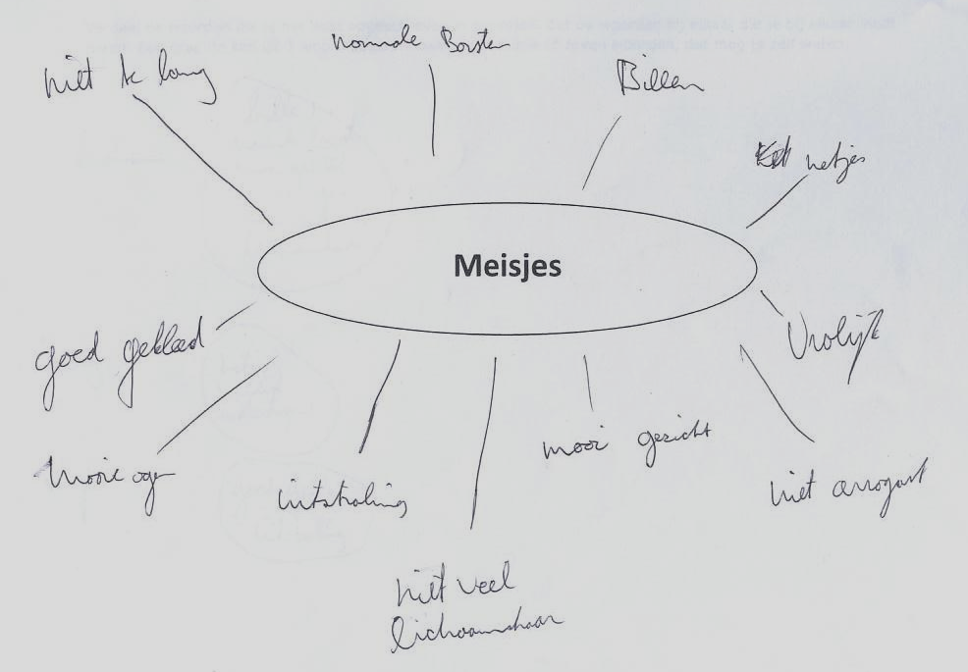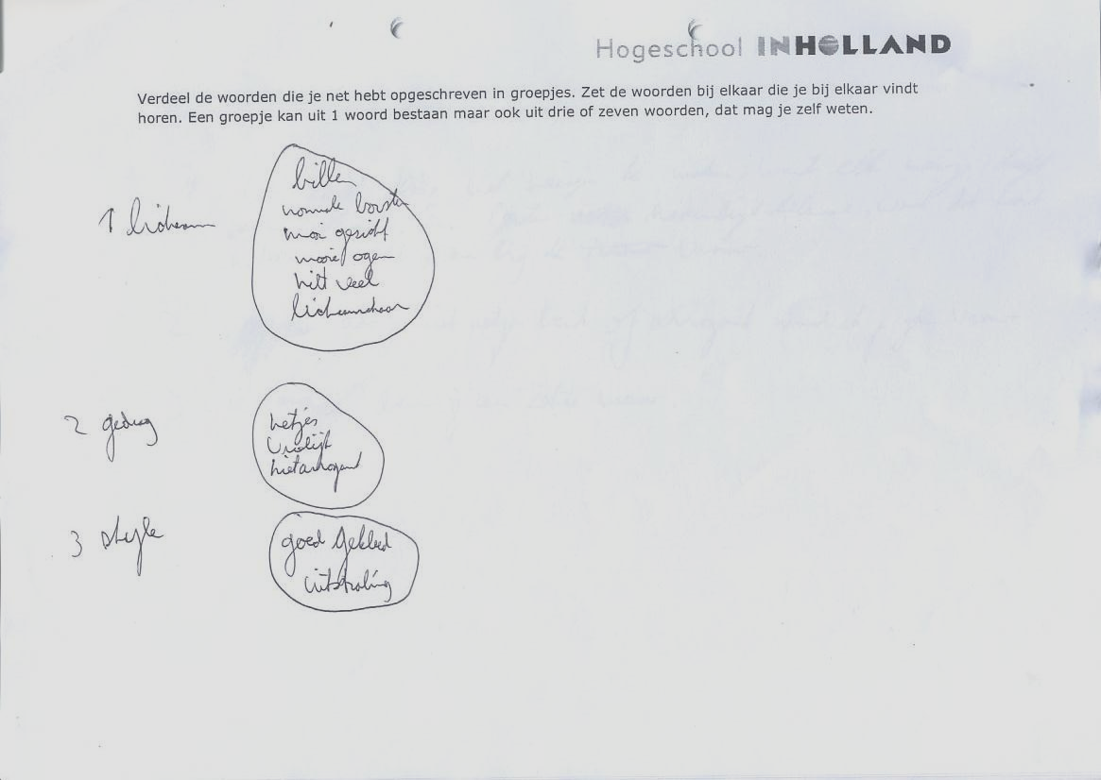
Figure 2: Left step 1: Collecting associations. Right step 2: clustering associations.

Step 3: Structure and label (10 minutes)
The pupils are asked to give a number to each of their clusters (the cluster label), to take over this number on another paper and to describe in one sentence what each cluster group has to do with the given stimulus word ‘girls’ or ‘boys’ (the statement) (figure 3).

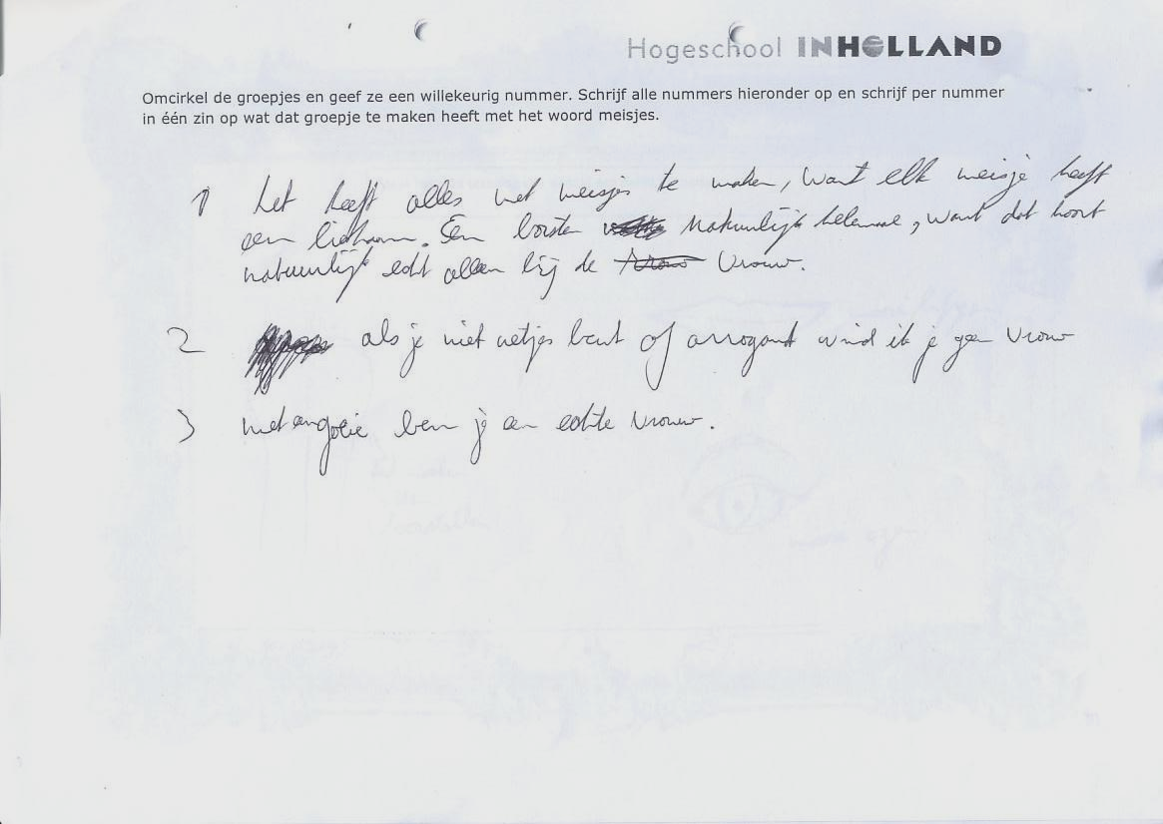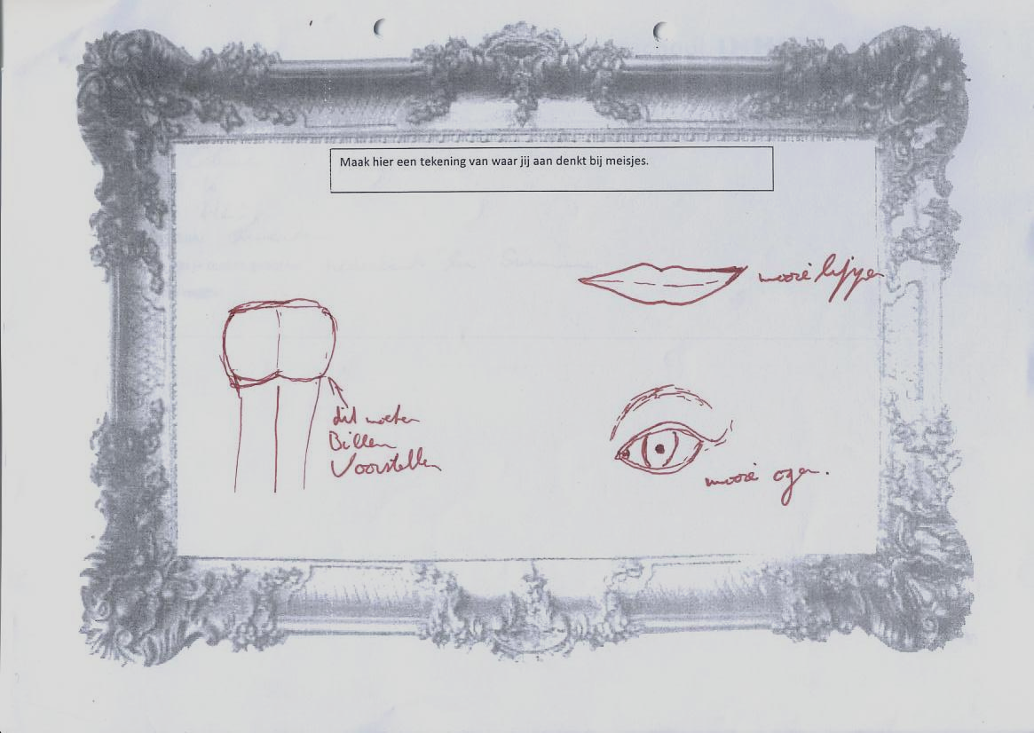
Figure 3: Left step 3: Structure and label. Right step 4: Drawing.

Step 4: Drawing
The boys and girls were asked to sketch a drawing of ‘boys’ (for girls) and ‘girls’ (for boys). They had to draw what they see in mind when they think of the stimulus word (figure 3).

The reason of using a writing and drawing task lies in the different functions of the human brain. The left part of the brain is involved with verbal, analytical, linear and math tasks. While the right part of the brain is involved with non-verbal, emotional and artistic tasks (Kuypers, 2005). Asking the pupils to do a writing and a drawing task should lead to a more complete view of their conceptions.
For the analysis of the data only step 3 (structure and label) and step 4 (drawing) is used. Because in step 3 the respondents have structured their thoughts by them self, thus it’s their conception of the stimulus word. The Dutch research team divided the sentences the respondents wrote down in step 3 into different themes. They did the same with all the elements the respondents drew. For example if a respondent drew lips or bottoms this was structured in the theme ‘looks’.

- Results

4.1 HC Test
To inventory the conceptions of boys and girls about each other the pupils carried out the HC Test individually. In The Netherlands 66 boys and 39 girls in the age of 12 to 17 years old participated of four different schools. In the Ukraine 26 boys and 40 girls in the age of 12 to 17 years old participated of two different schools. In figure 4 and 5 the results are shown divided by theme.

Figure 4: Girls with stimulus word ‘Boys’
Theme | The Netherlands (N=39) | Ukraine (N=40)
Looks | Girls like to see beautiful boys, with short styled hair, brand named clothing and with mussels. | Girls like to see that boys are hygienic styled.
Personality | - | Girls want to be protected by boys.
Behavior | Girls want to be brought home by the boy and they are not selfish in a relationship with a girl. | Girls want boys to be brave and want to be helped by boys when there are problems. They think that boys are sometimes selfish and they don’t think of the girls feelings.
Relationships | - | Girls expect that boys will take care of the girl and that he will protect her.
School | - | Girls in want boys with good education, concerning their future.
Sex | A couple of girls associated a boy with a drawing of a penis or a sentence with the words sperm and making babies. | Girls didn’t associate boys with sexual aspects.

Figure 5: Boys with stimulus word ‘Girls’
Theme | The Netherlands (N=66) | Ukraine (N=26)
Looks | Boys appoint in particular the feminine parts as breast and bottom, which they think are beautiful. Other typical feminine marks are also called. | Boys like to see a well-groomed and good looking girl, which defines beauty. They think that this is important.
Personality | Boys haven’t got any expectations of girls, but they describe their character: they are sweet, cute and they can be very jealous. | Boys have most of all the same opinions about what type of character a girl must have. They have to be smart and kind.
Behavior | Boys say that girls often do ‘typical girls things’ as shopping, sunbathing and makeovers. | Boys do see that girls from their country needs protection and that girls are good students.
Relationships | Boys associate relationships with sex, living together, pregnancy and twaddle. | Boys see it as when you have a family with a girl or where you can share love with and can be happy.
Sex | A few times boys are probably thinking of sex, when they talk about sex or when they draw masturbating girls. | Boys probably aren’t thinking of sex when they think of girls.

4.2 Development of educational means
The clustered conceptions of the pupils in the HC Test and the context analysis formed the bulk of ideas from which the conditions for the design of the communication message were chosen (see underneath).

Conditions for The Netherlands:
- Boys and girls see each other as sex objects.
- Good looking girls are important for boys.
- Boys and girls think mark clothes are important.
- Boys find besides the good look also the inner of girls important.
- Boys think that girls are different in their behavior (jealous and sensitive).
- Boys think that girl mustn’t be lazy and spoiled.
- Boys say that contact with girls at school, through msn and the telephone is important.

Conditions for Ukraine:
- Girls like boys that are nice and loving.
- Girls wish for smart boys with a good education or a good job.
- Boys expect from girls that they are smart.
- Boys think that cleverness is a part of the beauty of a girl.
- Boys wants girl to be taking good care of their appearance.
- Homosexuality is allowed and is becoming more and more noticeable at the streets and at the television.
- Pupils have a view in a western manner about sexuality.

The goal of the educational intervention to be developed was to realize understanding between boys and girls about each other. The ideology is that when boys and girls understand each other better and are aware of the differences between them, they could be able to provide their will and their bound. When boys and girls are more confident to each other it becomes easier for them to talk about sex and about making love with or without a condom.

  - The development of educational methods
The student team developed an interactive talking game in which boys and girls are standing across each other and discuss their differences supported by propositions, photo’s, quizzes and drama parts. The student team chose for those frames because it represents the living world of the pupils. Both Dutch pupils as Ukrainian pupils have to deal with many images on television and internet. The communication tool is produced as a manual for teachers.
In the workshop two games were pointed out: ‘Brains or beauty?’ and ‘Recognize the heterosexual’. The game ‘Brains or beauty’ is developed by the student team for Ukrainian pupils and has two main goals, based on the conditions for Ukraine explained in paragraph 4.2:
1. Pupils know that smart girls/boys haven’t always got good looks;
2. Pupils know that brains and looks are not related.
To reach the goals the student team developed an individual assignment for pupils on a piece of paper. On the paper are ten pictures of persons who are well known with Ukraine pupils, like singers, politicians and models. In Ukraine 31 boys and 26 girls attended this assignment. The pupils had to make couples of those persons and argue the kind of relation per couple. This assignment gave the opportunity to discuss relations between people; between girls, between boys and between boys and girls. The pupils remarked that there are four men and six woman on their paper, and they wondered how to finish the assignment well. Most of them made a couple of two woman, but wrote down that it’s only friendship. After this step the pupils had to choose one person where they would like to go for dinner with and they had to write down their arguments for the person of their choice. The student team asked this to let the pupils think about what they think is important by choosing relations and people. Conclusion is that the girls had arguments for inner aspects of boys and that boys had more arguments for the outside aspects of girls. Both girls and boys gave arguments why they made the couples and chose one person in particular.
The game ‘Recognize the homosexual’ is about coping with prejudices against homosexuals. The student team developed this game because homosexuality is a difficult issue in The Netherlands and Ukraine. In Ukraine homosexuality was a crime and punishable till 1991, because of its dependence of the Soviet Union. These days homosexuality in Ukraine is not forbidden, but the public is still intolerant towards homosexuals (Geocities, 2001). In The Netherlands the organization for homosexual youth ‘Out Way’ says the vision on homosexuality by Dutch people is still very negative (Out Way, 2008). The centre for lesbian and homosexual emancipation policy explains that homosexuality is still taboo among youth, and that bothers homosexual youth (Kenniscentrum Lesbisch en Homo-emancipatie beleid, 2008). The game ‘Recognize the homosexual’ has also two main goals:
1. Pupils know that there aren’t only straight relationships;
2. Pupils know that you cannot see if someone is straight or homosexual by their appearances.
Therefore the student team used the game ‘Recognize the straight one’, developed by the Dutch organization COC who works on the integration and emancipation of homosexuality. The goal of the game is to recognize the homosexuals and the heterosexuals among a group of pictures of 32 men and woman. The trick is that only two people are heterosexual, and all the other people are homosexual.
In The Netherlands the game is tested with 5 girls and 10 boys. The pupils got the assignment to recognize the hetero- and homosexuals among the pictures. They wrote down who they thought is heterosexual and who they thought is homosexual. The student team asked the pupils what they wrote down and why. The pupils gave arguments and came to the conclusion that it’s hard to judge from the outside.
The student team told the pupils that only two persons are heterosexual, most of them were surprised that all those people are homosexual. The student team had a conversation with the pupils students about this. They talked about judging from the outside. Most of the pupils realized that sexual inclination is not visible. Most of them said they would accept it as they have a homosexual classmate.

  - Ukrainian teachers and health organizations
In Ukraine the student team had a meeting with Ukrainian students and health organizations. Several people advised the team to not use the game about homosexuality. One of the reasons was that it’s not possible to discuss a certain topic with pupils beneath 16 years old without asking permission to the parents. Another reason was that people thought it could be seen as propaganda (promoting homosexuality). The orthodox religion was also mentioned, that relations between men and woman are for reproduction and that relations between men and between woman are seen as something bad. The team decided to not use the game with pupils in Ukraine.
Instead of testing the game with the pupils, the students inventoried the concepts of seven Ukrainian teachers about homosexuality by using the HC Test with the stimulus word ‘homosexuality’. Some of the results are shown in figure 6.

Figure 6: Teachers about ‘homosexuality’
 | Examples (N=7)
Woman | - Homosexuality is a mental defect.  - Risk to get aids/std  - Wrong raising  - Estrangement of the society
Men | - Wrong raising  - Leads to typical diseases, loneliness and drama  - Inborn physical or mental defect  - Most of the time addicted to drugs

Conclusion

The goal was to realize understanding between boys and girls about each other. When they understand each other better and are aware of the differences between them, they could be able to provide their will and their bound. It becomes clear from the tested games that in general Ukrainian boys think more of the inner aspects of girls then before. The boys and the girls both gave arguments for their choice, that strengthens them in relations with each other. Homosexuality is still taboo in Ukraine comparing to The Netherlands. Adults in Ukraine have prejudice about homosexuality and don’t discuss about it openly.
Young people are more often and earlier sexual active (Garssen, 2002). This can be a reason why boys think more of sex than girls. Because of this research it’s obvious that boys associate physical and sexual elements when they think of girls. Boys also associate elements of behavior and personality of girls, so there can’t be concluded that boys are sexualized. Sexualization means that the dignity of a person depends on the sexual behavior and attractiveness instead of other elements (American Psychological Association, Task Force on the Sexualization of Girls, 2007). Besides that boys have more visual capabilities while girls are stronger verbally. That can be a reason why boys have more eye for the female body and girls like to talk with other girls.
It seems that teachers should know more about homosexuality, because their thoughts about homosexuality are not all true. Next to knowledge it is recommended for teachers to have the skills and the instruments to talk about taboo subjects. With the results from this research project, past projects about how pupils think about life (Vallenga & De Vries, 2006), how teachers think about life and HIV/aids (Van der Geugten, 2006) it is relevant to investigate the teachers’ conceptions about teaching taboo subjects, to inventory their educational means and provide it.

Acknowledgements
The contributions of Esther Elfrink, Marieke Bosman and Alexandra Meijer to the research and development in this project are greatly acknowledged.
We thank the Lutheran Orphanage Home Amsterdam for their financial support. We thank the Lviv Inservice Teacher Training Institute, National Taras Shevchenko University Kiev (prof. Gorbachyk and prof. Ivanov), School 318 and School 2 for their cooperation.
We also thank: Pieter Nieuwland College, Hervormd Lyceum Zuid, Stebo B.V., SALUS Foundation, Transatlantic Partners Against Aids, Aids Foundation East West.

References

AD. (2007, 11 oktober). Scholieren veel te wulps. [Electronic version]. Algemeen Dagblad.

AFEW. (2007) HIV infection cases by main risc factor in Ukraine. AFEW. Retrieved from http://afew.org/russian/statistics/HIVTransmRoutes_UA.htm, 20 August 2008.

American Psychological Association, Task Force on the Sexualization of Girls. (2007). Report of the APA Task Force on the Sexualization of Girls. Washington, DC: American Psychological Association. Retrieved from www.apa.org/pi/wpo/sexualization.html, 16 September 2008.

Ausubel, David P. (1968). Educational Psychology. A cognitive view. In American Educational Research Association, 6(2), 287.

Beemen, L., van. (2001). Ontwikkelingspsychologie. Groningen: Wolters-Noordhoff BV.

Brink, J., Los, E. (2007, 13 december) Anno geschiedenis krant. [Electronic version]. Spits.

Brinkman, F. (2004). Schematisch stappenplan voor het ontwerpen van voorlichting. Hogeschool INHolland, opleiding Communicatie.

Brinkman, F., Goddijn, H., & Tarasov, V. (2005). Teenage Sex in Belarus: what should schools teach children? The making of a video movie based teaching strategy about aidsprevention for pupils in Belarus and the reactions of their teachers. Presented at the ATEE conference 2005, Amsterdam.

Boschhuizen, R., & Brinkman, F. (1995). Proposal for a teaching strategy based on preinstructional ideas
of pupils. environmental education: The use of pupils' ideas about cycles of nature and health. European
Journal of Teacher Education, 14(1), 45-55.

Doef, S., van der. (2003). Kleine mensen grote gevoelens, kinderen en hun seksualiteit. Amsterdam: De Brink, Uitgeverij Ploegsma BV.

Garssen, J. (2002). Tienermoeders: recente trends en mogelijke verklaringen. Bevolkingstrends, 1e kwartaal 2004. Retrieved from www.cbs.nl, 16th September 2008. Centraal Bureau voor de Statistiek.

Geocities. (2001). Homosexuality in Ukraine. Retrieved from
http://www.geocities.com/gayguideua/portfolio.html?200822, 22 September 2008.

Geugten, van der, J., Brinkman, F., & Jager, T. (2006). Teachers and student teachers in Belarus,
Ukraine, and the Netherlands use value dilemmas of life, developing HIV/AIDS related strategies for
education. Paper presented at the ATEE conference 2006, Slovenia.

Helden, van, J., Simons, A. (2007) Lesmateriaal gezondheidseducatie. Voortgezet onderwijs. Jeugd- en
jongerenwerk. GGD Hollands Midden.

Kenniscentrum Lesbisch en Homo-emancipatie beleid. (2008). Jongeren overzicht. Retrieved from
www.homo-emancipatie.nl/jongeren/overzicht.html, 15 september 2008.

Kievits, L., Huisman, L. & Brinkman, F. (1998). Pupils’ conceptions about food in contaminated areas. Paper presented at the ERIDOB conference 1998, Goteborg.

Kuyper, A. (2005). De functie van linker en rechter hersenhelft. Retrieved from www.synergy-at-work.nl,
16th September 2008. Zutphen: Synergy at Work.

Out Way. (2008). Homotolerantie daalt; voorlichting broodnodig!, Retrieved from www.outway.nl/website/OverOutway/Pressbox.php#92, 15 September 2008.

Pronk, I. (2007, 19 maart). Seksuele voorlichting / ’Het blijft tussen ouders en leerkracht in liggen’.
[Electronic version]. Trouw. 19 maart 2007.

Rigthart, H. (1998). Cultuur en mentaliteit in de lange jaren vijftig. Amsterdam University Press: Amsterdam.

Schellens, P. J., Klaassen, R., & Vries, S., de. (2000). Communicatiekundig ontwerpen; een kader. In P.
J. Schellens, R. Klaassen & S. Vries de (Eds.), Communicatiekundig ontwerpen (pp. 1-20). Assen: Van
Gorcum.

Shyyan O., Shyyan R. (1997). Certain Approaches to Enhancing Teachers’ Valeological Competence// Materials of the All-Ukrainian scientific conference “Optimization of the Physical Education Process in the System of Education” – Kyiv – Ternopil, 1997 (pp. 256-258).

Shyyan O. (2005). International Experience and Ukrainian Approach in Health Promotion through Physical Education // Prozdrowotny styl zycia - uwarunkowania spoleczne. – Gdansk, 2005 (pp. 133-139).

UNAIDS. (2008). Report on the global AIDS epidemic. UNAIDS/WHO. Retrieved from www.unaids.org, 20th August 2008.

Vallenga, M., Vries, de A. (2006). Everybody is in power to make their own life into a rainbow. Onderzoek naar denkbeelden van Nederlandse, Oekraïense en Wit-Russische middelbare scholieren. Hogeschool INHolland, opleiding Communicatie (bachelorthesis).

Vries, de, J. (2005). Gezondheidsbeleving en Aidsvoorlichting. INHolland university, School of Communication (bachelorthesis).

World Health Organization. (n.y.). Sexual health. Retrieved from http://www.who.int/reproductive-health/gender/sexualhealth.html#3, 14 October 2008.

Marieke Bosman, Esther Elfrink
Alexandra Meijer
Jolien van der Geugten, Thomas Jager, Fred Brinkman
Head of Life Competence department, Lviv In-service Teacher Training Institute Ukraine.
Pieter Nieuwland College (Amsterdam), Hervormd Lyceum Zuid (Amsterdam), Stebo B.V. (Amsterdam), Stedelijk Dalton College (Alkmaar).
School 318 (Kiev), school 2 (Lviv).
The manual of the talking game is available at the project website: www.surfgroepen.nl/sites/EastWest
School 318 (Kiev), school 2 (Lviv).
Hervormd Lyceum Zuid klas Havo 4

